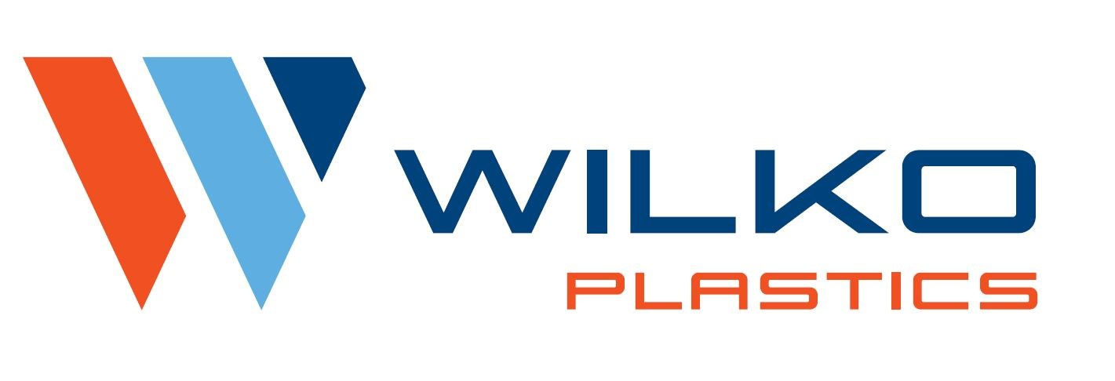
SUPPLIER MANUAL

INTRODUCTION
Revision Level: G 8/27/24

This manual shall be provided to suppliers of WILKO PLASTICS to communicate the Quality System Requirements and Assessment process.

Purchased materials and components are pertinent to the production process and scheduling commitments of WILKO PLASTICS Inc. (reference to follow as WILKO PLASTICS). The timeliness and quality of all materials and components are imperative to the operation of our organization. All suppliers must have effective operating policies and procedures in place that ensure all products supplied conform to stated requirements and certifications.

WILKO PLASTICS is committed to selecting suppliers that can demonstrate their full commitment and ability to comply with the requirements of this manual.

The WILKO PLASTICS Quality System Requirements are based upon existing quality system standard ISO-9001:2015 or IATF-16949:2016. WILKO PLASTICS uses this common assessment process to evaluate the efficacy of its Suppliers Quality Systems.

QUALITY SYSTEM EXPECTATIONS

REQUIREMENTS

- 100% Supplier performance.
2. Submission of necessary documents:

a. ISO 9001:2015 OR IATF 16949: 2016

b. Submissions: (when required)

1. PPAP For purchased parts
Evidence of approval to OEM material requirements
Certificates of analysis to material requirements
Reference AIAG PPAP Manual-Rev 4
2. Lab Accreditation ISO /IEC 17025:2017
3. Certificate of analysis per lot code supplied name of lab and revision level of testing
performed must be present on certificate.
4. SDS Documentation
5. NAFTA Certificate of Origin

3. Proper packaging, labeling (with WILKO PLASTICS part number) and quality of products and materials.

4. Wilko Plastics will communicate the requirement with each supplier to ensure that purchased
products, processes, and services conform to the current applicable statutory and regulatory
requirements in the country of receipt, the country of shipment, and the customer-identified country of destination, if provided.

If the customer defines special controls for certain products with statutory and regulatory
requirements, the WILKO PLASTICS shall ensure they are implemented and maintained as
defined, including at suppliers.

SELECTION CRITERIA FOR QUALITY SYSTEM ASSESSMENT

PURPOSE

To provide an effective method of monitoring supplier performance.

REQUIREMENTS`

The following conditions may warrant a Quality System Assessment:

- A new Supplier. (ISO 9001:2015 or IATF 16949:2016 certified)

- An existing Supplier that has had a significant organizational change or added a manufacturing facility.

- A Supplier with a significant drop in its performance rating.

ASSESSMENT REQUIREMENTS

REQUIREMENTS

The following steps ensure a successful assessment of the Supplier Quality System.

1 WILKO PLASTICS. will contact the supplier to discuss the need for an assessment and the
Corresponding requirements.

2. The supplier shall supply WILKO PLASTICS with an ISO 9001:2015 or IATF 16949: 2016 certificate. If not certified, a plan with timing will be required.

3. Provide notification to all key personnel necessary to attend introduction and summary meetings

EVALUATION OF SUPPLIERS

REQUIREMENTS

A. Supplier Performance Monitoring

1. Supplier performance will be monitored monthly. Any supplier with a rating below 90% will be contacted regarding the level of unsatisfactory performance.

B. Supplier Performance Criteria

1. Percent of on-time deliveries.
2. Percent of on-time certification deliveries.
3. Percent of Quality shipment approvals / Submission Performance.
4. Interruptions to WILKO PLASTICS customers.
5. Quality rating impact on WILKO PLASTICS customers.

C. Premium Freight Tracking

Records of premium freight costs incurred by WILKO PLASTICS shall be tracked on the Premium Freight Log.

D. Calculating Performance Ratings

A. Percent of On-Time Deliveries

1. Total number of on-time deliveries divided by total number of shipments.

B. Percent of On-Time Certifications

1. Total number of on-time certifications divided by total number of certifications received.

C. Percent of Quality Shipment Approvals

1. Total number of approvals divided by total number of shipments.

E. Review and Notification to Suppliers of Delivery Performance

1. Monthly Review - The Materials Department will review applicable Supplier Performance Data. If a supplier falls below minimum acceptance levels, a copy of the Customer Rating Report will be sent.

2. Supplier Performance Expectation – All suppliers are expected to achieve a Performance Rating of 100 percent.

PRODUCT IDENTIFICATION

REQUIREMENTS

A. Identification of Purchased Products or In-process Product

Purchased products are to be identified by the supplier using WILKO PLASTICS’s bar coding system prior to shipment. Products are to be identified as stipulated on the purchase order. All documents shall reference WILKO PLASTICS part numbers.

B. Identification of Raw Materials

Raw materials are to be identified by the Supplier using WILKO PLASTICS’s bar coding system prior to receipt. Raw materials are to be identified as stipulated on the purchase order.

C. Identification of Finished Product or Finished Assembly

Finished products or assemblies are identified by the Supplier as stipulated by WILKO PLASTICS.

D. Supplier Label Requirements

Reference Product Identification
Shelf-life identification when applicable

PRODUCT IDENTIFICATION

SUPPLIER LABEL REQUIREMENTS

- Symbology: AIAG (www.aiag.org).

SAMPLE LABELS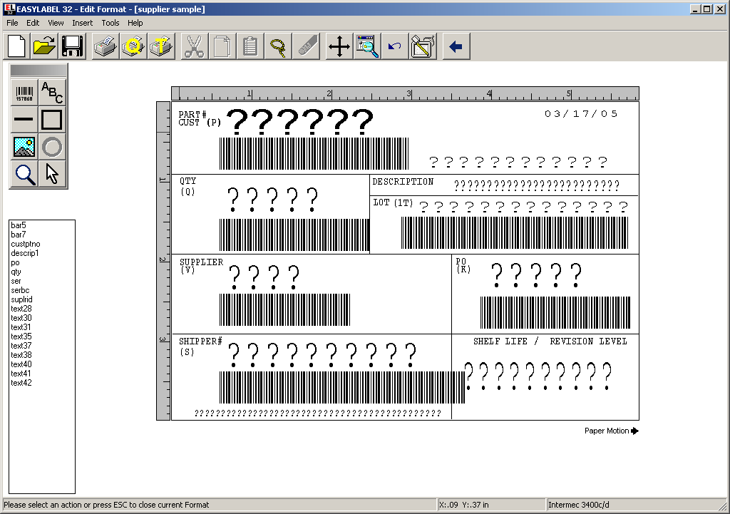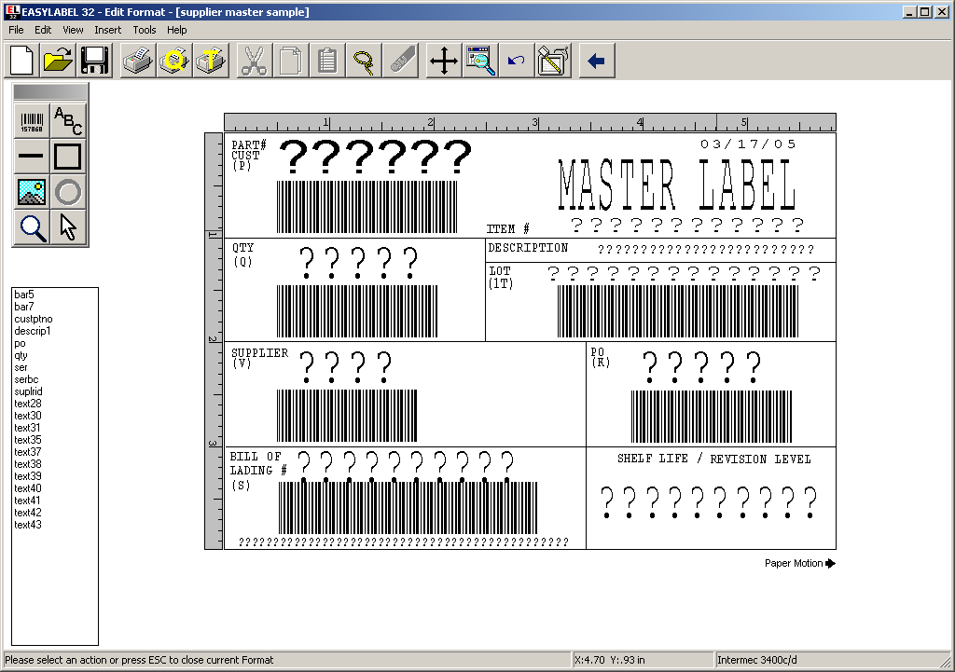

SCHEDULING OF SHIPMENTS

REQUIREMENTS

- During order placement, WILKO PLASTICS will provide sufficient information including quantity, delivery timing, proper material/purchased good nomenclature and required certifications. Confirmation will be required at time of
Order to establish timing acceptance.

- Failure to deliver raw material/purchased goods in a timely manner may necessitate premium freight. All such
Charges will be invoiced back to supplier at fault.

- Premium freight charges incurred due to quality issues or non-conforming product will also be invoiced to the supplier at fault.

SUPPLIER PREVENTIVE / CORRECTIVE ACTION REPORT

REQUIREMENTS

A. WILKO PLASTICS Reject/Hold Process

Upon receipt of suspect or known nonconforming material/product, WILKO PLASTICS will place product on hold or reject for disposition. RMA’s will be requested.

B. Supplier Notification

1. Verbal Contact: Advise of issue.
2. Written Notification
A DMN shall be e-mailed in the event nonconformances are detected.

C. Supplier Requirements/Corrective Action

The Supplier is to provide a written corrective action plan, (utilizing the supplied DMN), to WILKO PLASTICS within 15 business days.
1. Initial response within 24 hours.
2. Closed within 15 days.

PRODUCTION PART APPROVAL PROCESS (PPAP)

REQUIREMENTS

- Component Suppliers must submit Level 3 PPAP packages according to the latest revision from AIAG.
This will be submitted to and approved by WILKO PLASTICS’s Quality Department.

B. Supplier must perform annual validation for dimensional, material & performance testing requirements,
as noted on the design record (blueprint) or applicable specifications. Records must be readily available.

RAW MATERIAL CONSIDERATION PROCESS

REQUIREMENTS

A. Selection Criteria

- Suppliers must be a WILKO PLASTICS approved supplier, (refer to requirements, ISO 9001:2015 or equivalent.)

2. Required specifications must be approved to Engineering Standards as published by the O.E.M., or an
Accredited body if required.

3. Non-approved sources will receive a Request for Quote if a particular commodity is only available
Through that source.

4. PPAP Submissions to WILKO PLASTICS will include

- Evidence of approval to OEM material requirements.
- Certificates of analysis to material requirements per lot code supplied.
- Reference AIAG PPAP Manual-4th edition.
- SDS Documentation.
- IMDS.
- CAMDS (when required).

